Job Description

System Units

1.Storage tank

2.Filter

3.Pump

To monitor water level in storage tank by controlling compressor and pump they will controlled by their respective relays

**Relay for pump (R1)**

When user pushes a button and tanks level is above ##% R1 is active

**Relay for compressor (R2)**

When main tank is filled below ###% R2 will turn on

**Display things**

1. A total of &&& temperatures of various parts of the machine
2. Atmosphere humidity and temperature
3. TDS of the water after filtration
4. HP/LP are yet to be clarified

**Storing data in the SD card**

1. All the displayed things in an interval of &&& minute
2. Water dispensed for particular period of time

Flow chart for compressor

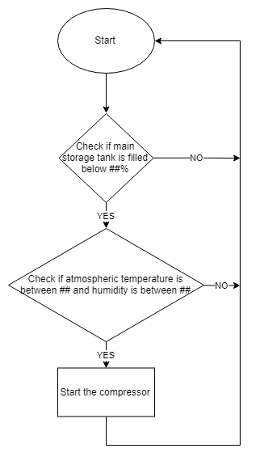

Flow chart for pump

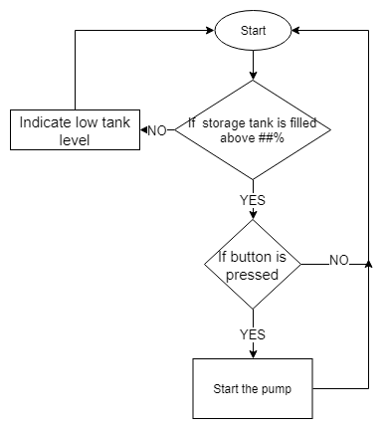

Block diagram

